
Monday Wednesday
CSAI2123
Introduction to Data Science
Assignment1
25
/
26
Faculty of Applied Sciences
Student Name:
Bachelor of Science in Computing
Student No.:
Academic Year 2025/2026 Sem.1
Class Time:

(i) To deal with plagiarism, a zero mark will be given if your copy someone else's work or you let someone copy your work.
(ii) Every assignment/project submission must be attached with a signed 'Declaration of Use of Generative AI'.

The table provided below shows the perceived importance of language by company ownership. The original data is provided in .xlsx file ('Example_Distributions_Wideformat.xlsx’) and you can download from the school Canvas. Your task is to replicate the example chart as closely as possible, ensuring consistency in chart type, color themes and overall design. Please utilize the dataset to create boxplots and violin plots.

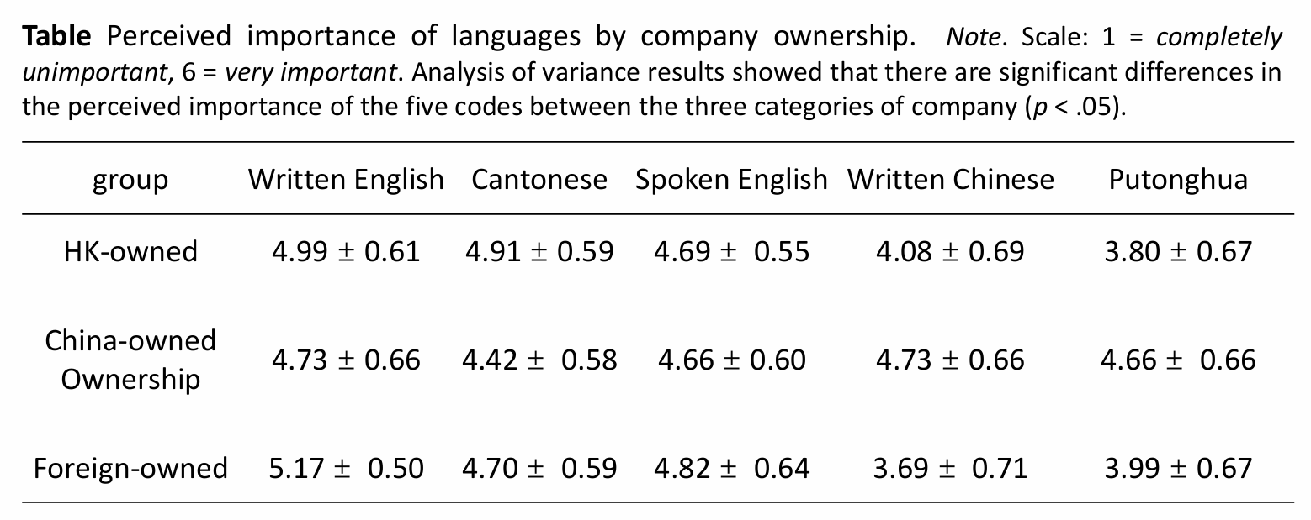

Please provide both the codes and the resulting visualization in your answer for marking.

Answer example: ====================================================
Codes: (Please take a screenshot of your code and paste it here.)
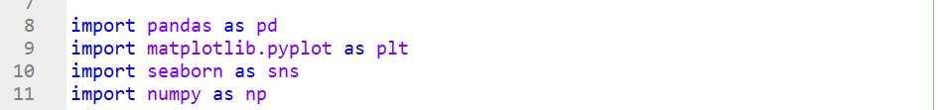

Figure: Please copy your figure and paste it here if the figure is required.
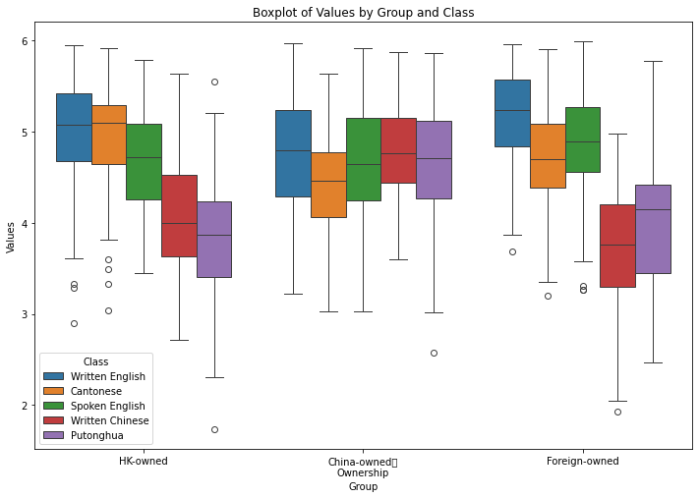
=======================================================================

1. Data Preprocessing: Table Merging and Wide-to-Long Transformation (15 Marks)
The file Example_Distributions_Wideformat.xlsx contains three sheets. Please complete the following preprocessing steps using pandas:
(1) Merge​ the data from all three sheets into a single DataFrame.
(2) Transform​ the merged data from wide format to long format (see the following reference figure).
(3) Export​ the processed DataFrame to a CSV file named Example_Distributions_longformat.csv.
Note: Your submitted answer must include the Python code used for this task, along with the output confirming the successful transformation using.head(10).
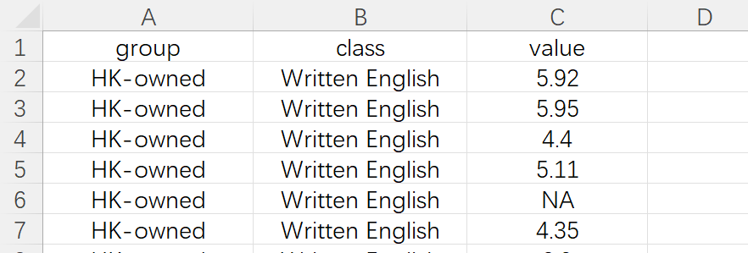

- A bar plot is a common type of data visualization that presents categorical data with rectangular bars. Each bar typically represents a category, and the length of the bar corresponds to the value of that category. Please use the generated data ('Example_Distributions_longformat.csv') to compute the average perceived importance of languages by different company ownership, then create the bar plot. (45 marks)
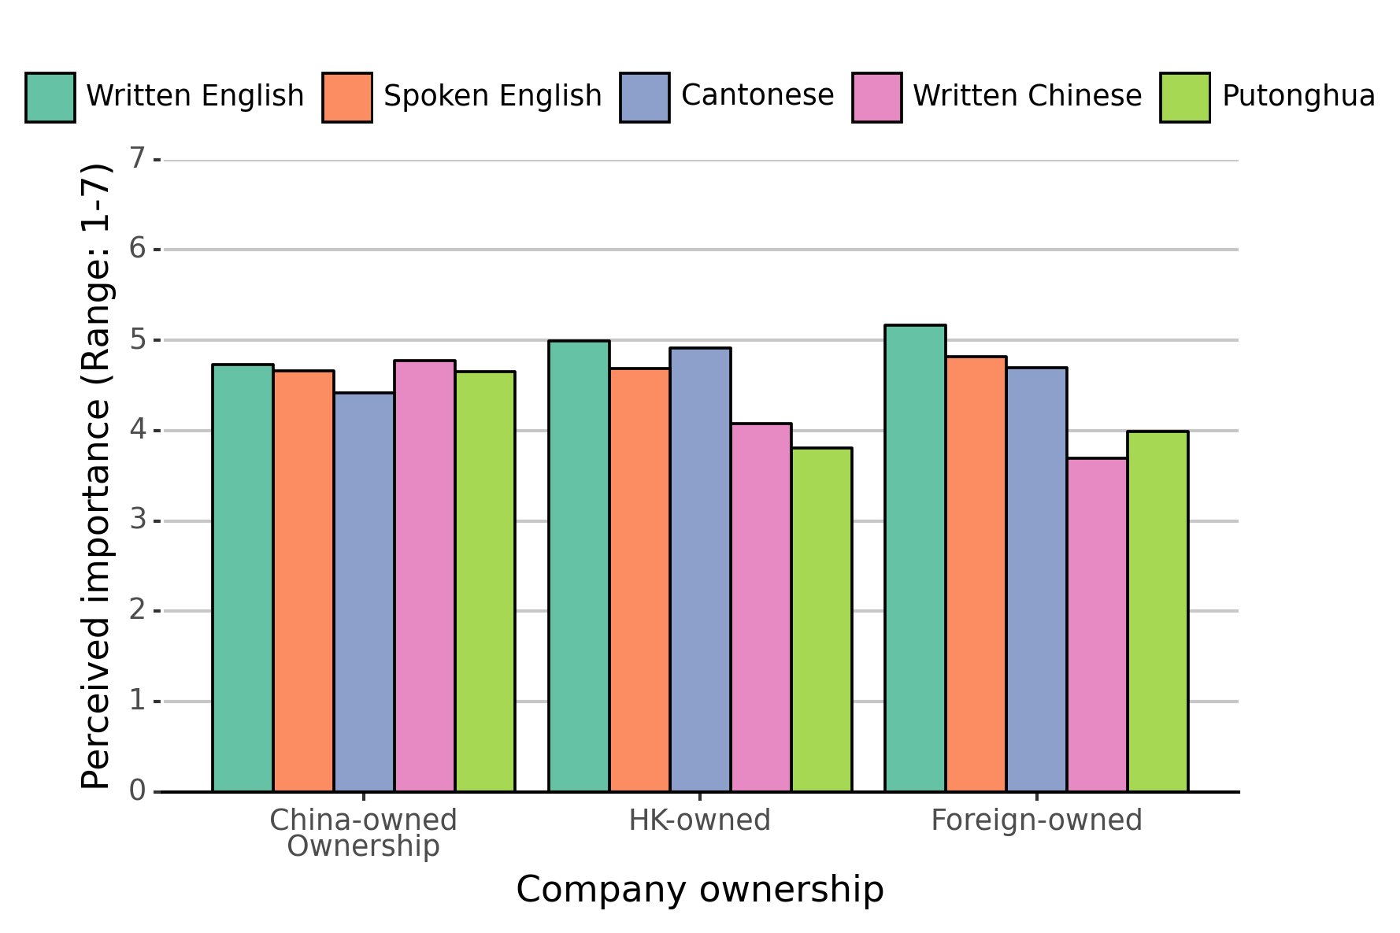
- Please use the matplotlib package to make the above grouped bar chart, and set the title of the figure to your personal information. The title must strictly follow this format:
"Note: this figure was produced by [Your Name] (ID: [Your Student ID]) on [Date]"
(Example: Note: this figure was produced by Jie Zhang (ID: P2026XXX) on 08/10/2026.) (20 marks)

- Please use the plotnine package to make the above grouped bar chart, and set the title of the figure to your personal information. The title must strictly follow this format:
"Note: this figure was produced by [Your Name] (ID: [Your Student ID]) on [Date]"
(Example: Note: this figure was produced by Jie Zhang (ID: P2026XXX) on 08/10/2026.) (20 marks)

(3) Please use Plotnine to add the error bar to the grouped bar chart in task (1) (the reference is shown in the following figure.) and set the title of the figure to your personal information. The title must strictly follow this format:
"Note: this figure was produced by [Your Name] (ID: [Your Student ID]) on [Date]"
(Example: Note: this figure was produced by Jie Zhang (ID: P2026XXX) on 08/10/2026.) (5 marks)
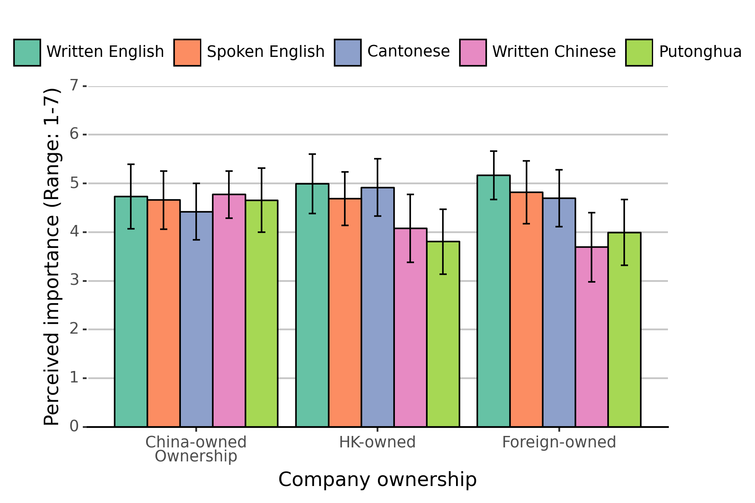

- A box plot can provide a concise way to represent the distribution of a dataset and identify any outliers or patterns within the data. Please use the generated data ('Example_Distributions_longformat.csv') to replicate the example box plot provided below. Please provide both the code used to create the chart and the resulting visualization in your answer for marking. You can employ plotnine to make the chart and set the title of the figure to your personal information. The title must strictly follow this format:
"Note: this figure was produced by [Your Name] (ID: [Your Student ID]) on [Date]"
(Example: Note: this figure was produced by Jie Zhang (ID: P2026XXX) on 08/10/2026.) (10 marks)

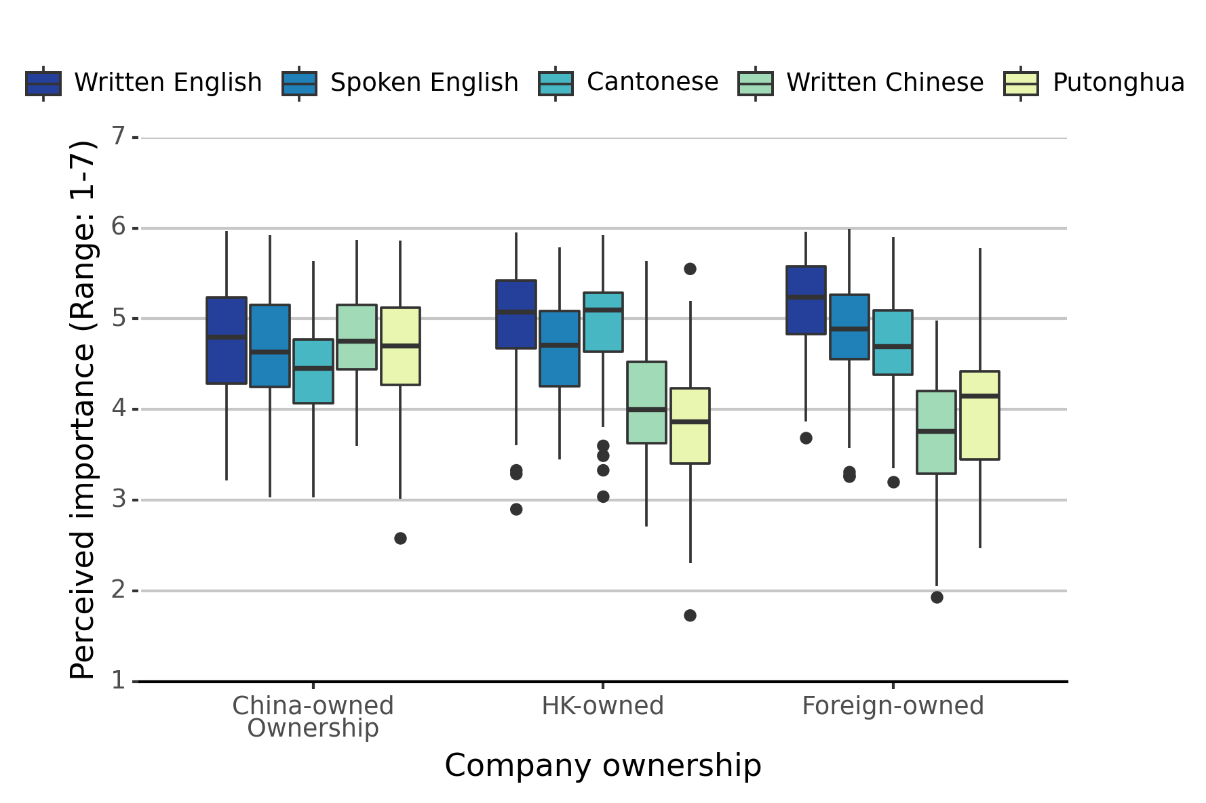

- A violin plot is a method of plotting numeric data and can be considered a combination of a box plot and a kernel density plot. It displays the distribution of the data across different categories or groups.
Please use the generated data ('Example_Distributions_longformat.csv') to replicate the example violin plot provided below. Please provide both the code used to create the chart and the resulting visualization in your answer for marking. You can employ plotnine to make the chart and set the title of the figure to your personal information. The title must strictly follow this format:
"Note: this figure was produced by [Your Name] (ID: [Your Student ID]) on [Date]"
(Example: Note: this figure was produced by Jie Zhang (ID: P2026XXX) on 08/10/2026.) (10 marks)
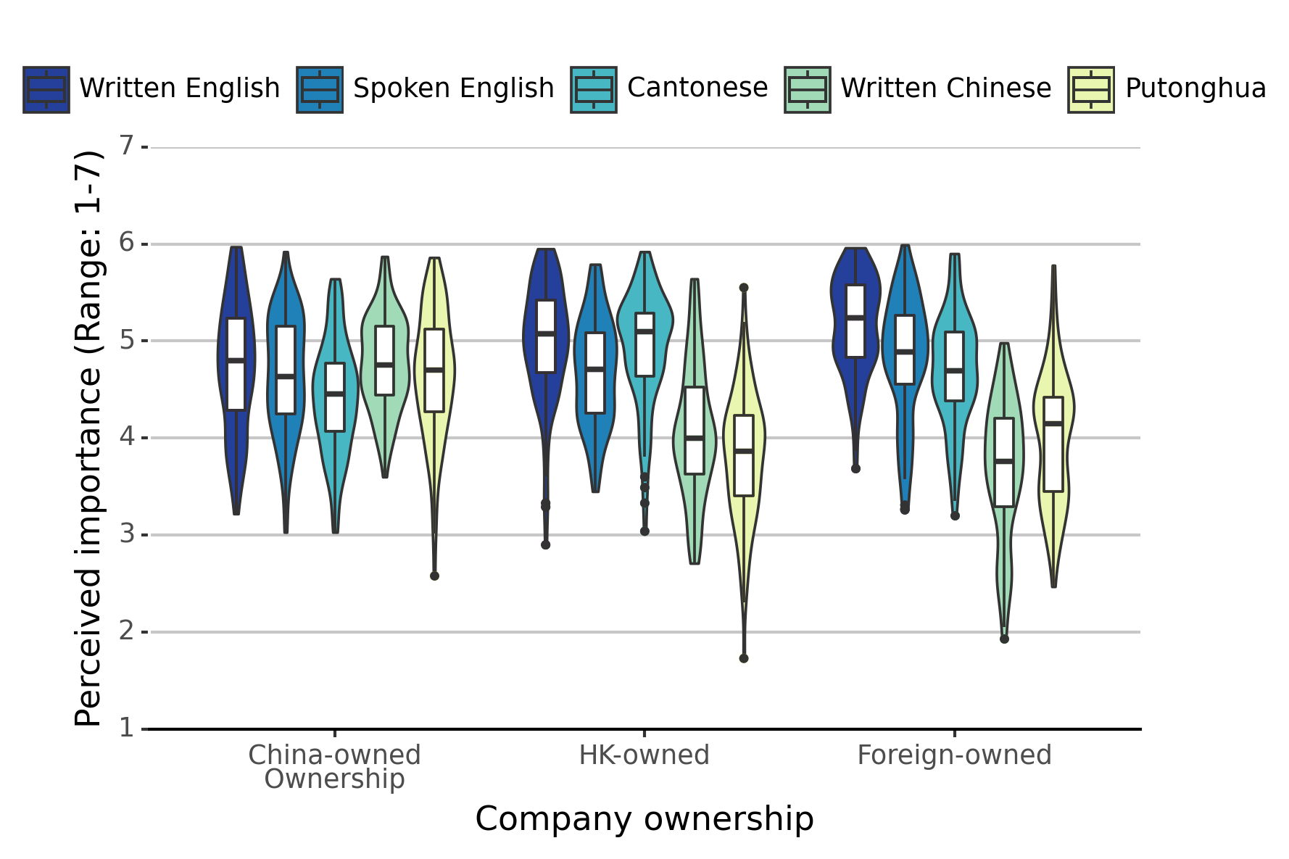

- A faceted chart, also known as a small multiples chart or trellis chart, is a visualization technique that involves splitting a single plot into multiple smaller subplots based on different categories or groupings in the data. Each subplot typically represents a subset of the data based on a shared categorical variable. Facets allow you to compare patterns and trends across different groups more easily than in a single plot.

In the chart, please use ["CO","HK","FO"] to replace ['China-owned\nOwnership', 'HK-owned', 'Foreign-owned'] for clear visualization. Please use the generated data ('Example_Distributions_longformat.csv') to replicate the example faceted box chart provided below. Please provide both the code used to create the chart and the resulting visualization in your answer for marking, and set the title of the figure to your personal information. The title must strictly follow this format:
"Note: this figure was produced by [Your Name] (ID: [Your Student ID]) on [Date]"
(Example: Note: this figure was produced by Jie Zhang (ID: P2026XXX) on 08/10/2026.) (20 marks)
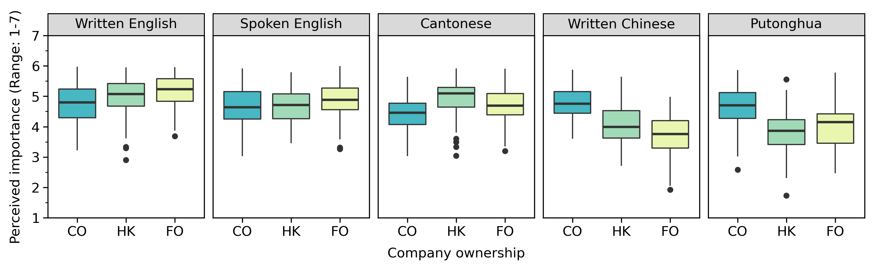
(1) Please use the generated data ('Example_Distributions.csv') to employ plotnine to make the above chart. (10 marks)

(2) Please use the generated data ('Example_Distributions.csv') to employ matplotlib to make the above chart. (10 marks)

Declaration of the Use of Generative AI for Assessment Work
Student name: | _________________________________________
Student ID: | _________________________________________
Module Code: | _________________________________________
Assessment Title: | _____________________________________________________________________________________

Please make sure you understand the policy about using generative AI, and such use must be explicitly acknowledged. The teacher/supervisor responsible for the assessment will provide specific guidance regarding acceptable usage, based on the module learning outcomes and marking criteria of the assessment. Failure to follow the rules for your work constitutes academic dishonesty.
Please tick either one below.
☐ I have used generative AI in this assessment work
☐ I did not use generative AI in this assessment work (please go to sign)
Generative AI tool used (name and version): | ________________________________________________________
For each relevant area, briefly describe how the information was generated, as well as explain how the output was used in your work. Put N/A if not appropriate.
Type of Usage | Done by AI tools | Done by student
Brainstorming and idea generation
Rephrasing text or formulas or generating text applied directly to the task
Generating literature/background review
Coding programming tasks
Producing diagrams/figures
Analysing data
Other (please specify):

Student signature:
Date:

